13.92: Using the notation 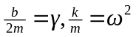 and taking derivatives of Eq. (13.42) (setting the phase angle 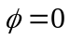does not affect the result),

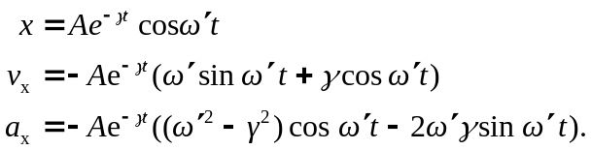

Using these expression in the left side of Eq. (13.41),

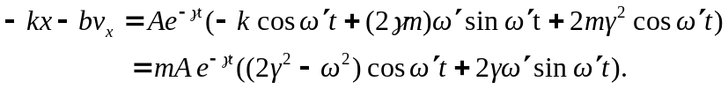

The factor 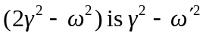(this is Eq. (13.43)), and so

